Purpose:

The purpose of this lab is to configure a stub area, a totally stub area, and a not-so-stubby area into a network of routers. Also, to configure EIGRP or RIP outside of the NSSA. I personally used EIGRP.

Background:

We used OSPF in this lab and we made different areas with the OSPF. There was a total of 4 different areas in the lab. Area 0 is called the backbone area. Area 1 is called the stub area. Area 2 is called the Not-So-Stubby-Area (NSSA). Area 3 is called the Totally Stubby area. The purpose of a Stub area is to not allow advertisements of external routes. This means that it should not see that there is an extra router on the outside of the network. If it allows the router to see networks on the outside of the main network, then the database will fill up too much and it will be overloaded and become slower. You don’t want to friend random people because their feeds will distract you and overload you from the things you actually want to see when you’re on social media. This is the same with the routers, only they don’t care about the different routes on the outside of the network. Now, totally stubby areas are even more protected than the normal stub areas. They are like the introverted kid who only has his friends friended on social media, and not trying to make new friends. Stub areas filter out these packets called LSA’s, specifically type 3 LSA’s. But totally stubby areas filter out type 3 LSA’s as well as type 5 LSA’s. This helps a lot with the routing table and not filling it up with random unnecessary routes. A Not-So-Stubby-Area is different than a stub area and a totally stubby area. An NSSA allows external routes to be “injected” into a normal stub area. These external routes can be almost anything, but for this lab, I chose EIGRP. EIGRP is very similar to OSPF, but we use OSPF more because it is easier to understand and implement. Now, going back to the NSSA, in one of those areas, they create a new LSA, which is LSA type 7. LSA type 7’s are only used in NSSA, so when the router in between routers has to send a packet, the router changes it to a type 5 LSA. The router in between the 2 areas is called an area border router (ABR), and the router that connects to the outside route is called an autonomous system boundary router (ASBR). There is also an area called a NSSA totally stubby area, but we didn’t use that for this lab. A NSSA totally stub area is when no inter-area routes are allowed. This means that when shown in the routing table, the routes are shown as default routes. Here is an easy list to see all of the LSA types allowed in each area.

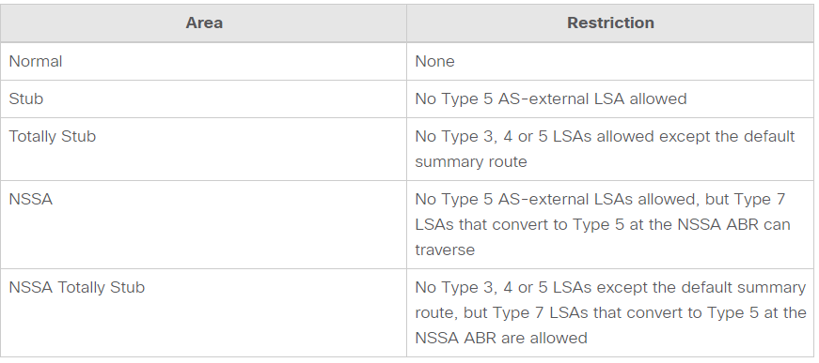

Lab Summary:

We set up 3 routers in area 1 (stub area), 4 routers in area 0 (backbone area), 3 routers in area 2 (NSSA), and 2 routers in area 3 (totally stubby area). I also configured ospf into all routers except one in which I configured EIGRP into it. I was also able to ping all routers from all routers. From the stub area, the IP route of the EIGRP router was just a default route.

Lab Commands:

|  |  |
| --- | --- |
| Router ospf 1 | It gets from configuration terminal to the ospf interface |
| Ip ospf 1 area 0 | It sets the specific interface to a specific area |
| Area 1 stub | It sets the specified area to a stub area |
| Area 1 nssa | It sets the specified area to a not so stubby area |
| Area 1 stub no summary | It sets the specified area to a totally stub area |
| Router eigrp | It gets into the eigrp interface |
| Redistribute eigrp 1 subnets | It redistributes EIGRP into OSPF so the EIGRP router gets the routes from the OSPF routers |
| Redistribute ospf 1 metric 1000 33 255 1 1500 | It puts in OSPF to EIGRP |

Network Diagram:

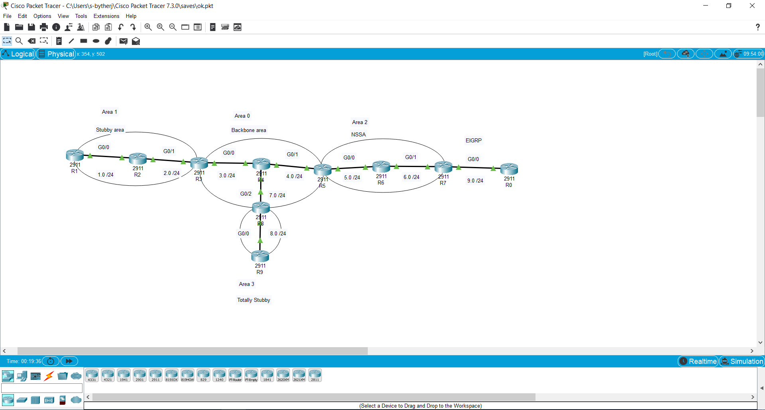

Configurations:

Router 1:

interface GigabitEthernet0/0

ip address 192.168.1.1 255.255.255.0

ip ospf 1 area 1

duplex auto

speed auto

interface GigabitEthernet0/1

no ip address

duplex auto

speed auto

shutdown

interface GigabitEthernet0/2

no ip address

duplex auto

speed auto

shutdown

interface Vlan1

no ip address

shutdown

router ospf 1

router-id 1.1.1.1

log-adjacency-changes

area 1 stub

Gateway of last resort is 192.168.1.2 to network 0.0.0.0

192.168.1.0/24 is variably subnetted, 2 subnets, 2 masks

C 192.168.1.0/24 is directly connected, GigabitEthernet0/0

L 192.168.1.1/32 is directly connected, GigabitEthernet0/0

O 192.168.2.0/24 [110/2] via 192.168.1.2, 00:11:42, GigabitEthernet0/0

O IA 192.168.3.0/24 [110/3] via 192.168.1.2, 00:11:42, GigabitEthernet0/0

O IA 192.168.4.0/24 [110/4] via 192.168.1.2, 00:11:42, GigabitEthernet0/0

O IA 192.168.5.0/24 [110/5] via 192.168.1.2, 00:11:42, GigabitEthernet0/0

O IA 192.168.6.0/24 [110/6] via 192.168.1.2, 00:11:42, GigabitEthernet0/0

O IA 192.168.7.0/24 [110/4] via 192.168.1.2, 00:11:42, GigabitEthernet0/0

O IA 192.168.8.0/24 [110/5] via 192.168.1.2, 00:11:42, GigabitEthernet0/0

O*IA 0.0.0.0/0 [110/3] via 192.168.1.2, 00:11:42, GigabitEthernet0/0

Router 2:

interface GigabitEthernet0/0

ip address 192.168.1.2 255.255.255.0

duplex auto

speed auto

interface GigabitEthernet0/1

ip address 192.168.2.1 255.255.255.0

duplex auto

speed auto

interface GigabitEthernet0/2

no ip address

duplex auto

speed auto

shutdown

interface Vlan1

no ip address

shutdown

router ospf 1

router-id 2.2.2.2

log-adjacency-changes

area 1 stub

network 192.168.2.0 0.0.0.255 area 1

network 192.168.1.0 0.0.0.255 area 1

Gateway of last resort is 192.168.2.2 to network 0.0.0.0

192.168.1.0/24 is variably subnetted, 2 subnets, 2 masks

C 192.168.1.0/24 is directly connected, GigabitEthernet0/0

L 192.168.1.2/32 is directly connected, GigabitEthernet0/0

192.168.2.0/24 is variably subnetted, 2 subnets, 2 masks

C 192.168.2.0/24 is directly connected, GigabitEthernet0/1

L 192.168.2.1/32 is directly connected, GigabitEthernet0/1

O IA 192.168.3.0/24 [110/2] via 192.168.2.2, 00:23:45, GigabitEthernet0/1

O IA 192.168.4.0/24 [110/3] via 192.168.2.2, 00:23:30, GigabitEthernet0/1

O IA 192.168.5.0/24 [110/4] via 192.168.2.2, 00:23:30, GigabitEthernet0/1

O IA 192.168.6.0/24 [110/5] via 192.168.2.2, 00:23:30, GigabitEthernet0/1

O IA 192.168.7.0/24 [110/3] via 192.168.2.2, 00:23:30, GigabitEthernet0/1

O IA 192.168.8.0/24 [110/4] via 192.168.2.2, 00:23:30, GigabitEthernet0/1

O*IA 0.0.0.0/0 [110/2] via 192.168.2.2, 00:23:45, GigabitEthernet0/1

Router 3:

interface GigabitEthernet0/0

ip address 192.168.3.1 255.255.255.0

ip ospf 1 area 0

duplex auto

speed auto

interface GigabitEthernet0/1

ip address 192.168.2.2 255.255.255.0

ip ospf 1 area 1

duplex auto

speed auto

interface GigabitEthernet0/2

no ip address

duplex auto

speed auto

shutdown

interface Vlan1

no ip address

shutdown

router ospf 1

router-id 3.3.3.3

log-adjacency-changes

area 1 stub

Gateway of last resort is not set

O 192.168.1.0/24 [110/2] via 192.168.2.1, 00:15:00, GigabitEthernet0/1

192.168.2.0/24 is variably subnetted, 2 subnets, 2 masks

C 192.168.2.0/24 is directly connected, GigabitEthernet0/1

L 192.168.2.2/32 is directly connected, GigabitEthernet0/1

192.168.3.0/24 is variably subnetted, 2 subnets, 2 masks

C 192.168.3.0/24 is directly connected, GigabitEthernet0/0

L 192.168.3.1/32 is directly connected, GigabitEthernet0/0

O 192.168.4.0/24 [110/2] via 192.168.3.2, 00:24:57, GigabitEthernet0/0

O IA 192.168.5.0/24 [110/3] via 192.168.3.2, 00:24:57, GigabitEthernet0/0

O IA 192.168.6.0/24 [110/4] via 192.168.3.2, 00:24:57, GigabitEthernet0/0

O 192.168.7.0/24 [110/2] via 192.168.3.2, 00:24:57, GigabitEthernet0/0

O IA 192.168.8.0/24 [110/3] via 192.168.3.2, 00:24:57, GigabitEthernet0/0

O E2 192.168.9.0/24 [110/20] via 192.168.3.2, 00:24:57, GigabitEthernet0/0

Router 4:

interface GigabitEthernet0/0

ip address 192.168.3.2 255.255.255.0

duplex auto

speed auto

interface GigabitEthernet0/1

ip address 192.168.4.1 255.255.255.0

duplex auto

speed auto

interface GigabitEthernet0/2

ip address 192.168.7.1 255.255.255.0

duplex auto

speed auto

interface Vlan1

no ip address

shutdown

router ospf 1

router-id 4.4.4.4

log-adjacency-changes

network 192.168.3.0 0.0.0.255 area 0

network 192.168.4.0 0.0.0.255 area 0

network 192.168.7.0 0.0.0.255 area 0

Gateway of last resort is not set

O IA 192.168.1.0/24 [110/3] via 192.168.3.1, 00:17:32, GigabitEthernet0/0

O IA 192.168.2.0/24 [110/2] via 192.168.3.1, 00:27:02, GigabitEthernet0/0

192.168.3.0/24 is variably subnetted, 2 subnets, 2 masks

C 192.168.3.0/24 is directly connected, GigabitEthernet0/0

L 192.168.3.2/32 is directly connected, GigabitEthernet0/0

192.168.4.0/24 is variably subnetted, 2 subnets, 2 masks

C 192.168.4.0/24 is directly connected, GigabitEthernet0/1

L 192.168.4.1/32 is directly connected, GigabitEthernet0/1

O IA 192.168.5.0/24 [110/2] via 192.168.4.2, 00:27:02, GigabitEthernet0/1

O IA 192.168.6.0/24 [110/3] via 192.168.4.2, 00:27:02, GigabitEthernet0/1

192.168.7.0/24 is variably subnetted, 2 subnets, 2 masks

C 192.168.7.0/24 is directly connected, GigabitEthernet0/2

L 192.168.7.1/32 is directly connected, GigabitEthernet0/2

O IA 192.168.8.0/24 [110/2] via 192.168.7.2, 00:27:02, GigabitEthernet0/2

O E2 192.168.9.0/24 [110/20] via 192.168.4.2, 00:27:02, GigabitEthernet0/1

Router 5:

interface GigabitEthernet0/0

ip address 192.168.5.1 255.255.255.0

ip ospf 1 area 2

duplex auto

speed auto

interface GigabitEthernet0/1

ip address 192.168.4.2 255.255.255.0

ip ospf 1 area 0

duplex auto

speed auto

interface GigabitEthernet0/2

no ip address

duplex auto

speed auto

shutdown

interface Vlan1

no ip address

shutdown

router ospf 1

router-id 5.5.5.5

log-adjacency-changes

area 2 nssa

Gateway of last resort is not set

O IA 192.168.1.0/24 [110/4] via 192.168.4.1, 00:18:35, GigabitEthernet0/1

O IA 192.168.2.0/24 [110/3] via 192.168.4.1, 00:28:15, GigabitEthernet0/1

O 192.168.3.0/24 [110/2] via 192.168.4.1, 00:28:15, GigabitEthernet0/1

192.168.4.0/24 is variably subnetted, 2 subnets, 2 masks

C 192.168.4.0/24 is directly connected, GigabitEthernet0/1

L 192.168.4.2/32 is directly connected, GigabitEthernet0/1

192.168.5.0/24 is variably subnetted, 2 subnets, 2 masks

C 192.168.5.0/24 is directly connected, GigabitEthernet0/0

L 192.168.5.1/32 is directly connected, GigabitEthernet0/0

O 192.168.6.0/24 [110/2] via 192.168.5.2, 00:28:10, GigabitEthernet0/0

O 192.168.7.0/24 [110/2] via 192.168.4.1, 00:28:15, GigabitEthernet0/1

O IA 192.168.8.0/24 [110/3] via 192.168.4.1, 00:28:15, GigabitEthernet0/1

O N2 192.168.9.0/24 [110/20] via 192.168.5.2, 00:28:10, GigabitEthernet0/0

Router 6:

interface GigabitEthernet0/0

ip address 192.168.5.2 255.255.255.0

duplex auto

speed auto

interface GigabitEthernet0/1

ip address 192.168.6.1 255.255.255.0

duplex auto

speed auto

interface GigabitEthernet0/2

no ip address

duplex auto

speed auto

shutdown

interface Vlan1

no ip address

shutdown

router ospf 1

router-id 6.6.6.6

log-adjacency-changes

area 2 nssa

network 192.168.5.0 0.0.0.255 area 2

network 192.168.6.0 0.0.0.255 area 2

Gateway of last resort is not set

O IA 192.168.1.0/24 [110/5] via 192.168.5.1, 00:19:47, GigabitEthernet0/0

O IA 192.168.2.0/24 [110/4] via 192.168.5.1, 00:29:28, GigabitEthernet0/0

O IA 192.168.3.0/24 [110/3] via 192.168.5.1, 00:29:28, GigabitEthernet0/0

O IA 192.168.4.0/24 [110/2] via 192.168.5.1, 00:29:28, GigabitEthernet0/0

192.168.5.0/24 is variably subnetted, 2 subnets, 2 masks

C 192.168.5.0/24 is directly connected, GigabitEthernet0/0

L 192.168.5.2/32 is directly connected, GigabitEthernet0/0

192.168.6.0/24 is variably subnetted, 2 subnets, 2 masks

C 192.168.6.0/24 is directly connected, GigabitEthernet0/1

L 192.168.6.1/32 is directly connected, GigabitEthernet0/1

O IA 192.168.7.0/24 [110/3] via 192.168.5.1, 00:29:28, GigabitEthernet0/0

O IA 192.168.8.0/24 [110/4] via 192.168.5.1, 00:29:28, GigabitEthernet0/0

O N2 192.168.9.0/24 [110/20] via 192.168.6.2, 00:29:38, GigabitEthernet0/1

Router 7:

interface GigabitEthernet0/0

ip address 192.168.9.1 255.255.255.0

duplex auto

speed auto

interface GigabitEthernet0/1

ip address 192.168.6.2 255.255.255.0

ip ospf 1 area 2

duplex auto

interface GigabitEthernet0/2

no ip address

duplex auto

shutdown

interface Vlan1

no ip address

shutdown

router eigrp 1

redistribute ospf 1 metric 1000 33 255 1 1500

network 192.168.9.0

router ospf 1

router-id 7.7.7.7

log-adjacency-changes

area 2 nssa

redistribute eigrp 1 subnets

Gateway of last resort is not set

O IA 192.168.1.0/24 [110/6] via 192.168.6.1, 00:20:59, GigabitEthernet0/1

O IA 192.168.2.0/24 [110/5] via 192.168.6.1, 00:30:40, GigabitEthernet0/1

O IA 192.168.3.0/24 [110/4] via 192.168.6.1, 00:30:40, GigabitEthernet0/1

O IA 192.168.4.0/24 [110/3] via 192.168.6.1, 00:30:40, GigabitEthernet0/1

O 192.168.5.0/24 [110/2] via 192.168.6.1, 00:30:50, GigabitEthernet0/1

192.168.6.0/24 is variably subnetted, 2 subnets, 2 masks

C 192.168.6.0/24 is directly connected, GigabitEthernet0/1

L 192.168.6.2/32 is directly connected, GigabitEthernet0/1

O IA 192.168.7.0/24 [110/4] via 192.168.6.1, 00:30:40, GigabitEthernet0/1

O IA 192.168.8.0/24 [110/5] via 192.168.6.1, 00:30:40, GigabitEthernet0/1

192.168.9.0/24 is variably subnetted, 2 subnets, 2 masks

C 192.168.9.0/24 is directly connected, GigabitEthernet0/0

L 192.168.9.1/32 is directly connected, GigabitEthernet0/0

Router 8:

interface GigabitEthernet0/0

ip address 192.168.8.1 255.255.255.0

ip ospf 1 area 3

duplex auto

speed auto

interface GigabitEthernet0/1

no ip address

duplex auto

speed auto

shutdown

interface GigabitEthernet0/2

ip address 192.168.7.2 255.255.255.0

ip ospf 1 area 0

duplex auto

speed auto

interface Vlan1

no ip address

shutdown

router ospf 1

router-id 8.8.8.8

log-adjacency-changes

area 3 stub no-summary

Gateway of last resort is not set

O IA 192.168.1.0/24 [110/4] via 192.168.7.1, 00:22:29, GigabitEthernet0/2

O IA 192.168.2.0/24 [110/3] via 192.168.7.1, 00:31:59, GigabitEthernet0/2

O 192.168.3.0/24 [110/2] via 192.168.7.1, 00:31:59, GigabitEthernet0/2

O 192.168.4.0/24 [110/2] via 192.168.7.1, 00:31:59, GigabitEthernet0/2

O IA 192.168.5.0/24 [110/3] via 192.168.7.1, 00:31:59, GigabitEthernet0/2

O IA 192.168.6.0/24 [110/4] via 192.168.7.1, 00:31:59, GigabitEthernet0/2

192.168.7.0/24 is variably subnetted, 2 subnets, 2 masks

C 192.168.7.0/24 is directly connected, GigabitEthernet0/2

L 192.168.7.2/32 is directly connected, GigabitEthernet0/2

192.168.8.0/24 is variably subnetted, 2 subnets, 2 masks

C 192.168.8.0/24 is directly connected, GigabitEthernet0/0

L 192.168.8.1/32 is directly connected, GigabitEthernet0/0

O E2 192.168.9.0/24 [110/20] via 192.168.7.1, 00:31:59, GigabitEthernet0/2

Router 9:

interface GigabitEthernet0/0

ip address 192.168.8.2 255.255.255.0

duplex auto

speed auto

interface GigabitEthernet0/1

no ip address

duplex auto

speed auto

shutdown

interface GigabitEthernet0/2

no ip address

duplex auto

speed auto

shutdown

interface Vlan1

no ip address

shutdown

router ospf 1

router-id 9.9.9.9

log-adjacency-changes

area 3 stub no-summary

network 192.168.8.0 0.0.0.255 area 3

Gateway of last resort is 192.168.8.1 to network 0.0.0.0

192.168.8.0/24 is variably subnetted, 2 subnets, 2 masks

C 192.168.8.0/24 is directly connected, GigabitEthernet0/0

L 192.168.8.2/32 is directly connected, GigabitEthernet0/0

O*IA 0.0.0.0/0 [110/2] via 192.168.8.1, 00:33:19, GigabitEthernet0/0

Router 0:

interface GigabitEthernet0/0

ip address 192.168.9.2 255.255.255.0

duplex auto

speed auto

interface GigabitEthernet0/1

no ip address

duplex auto

speed auto

shutdown

interface GigabitEthernet0/2

no ip address

duplex auto

speed auto

shutdown

interface Vlan1

no ip address

shutdown

router eigrp 1

network 192.168.9.0

Gateway of last resort is not set

D EX 192.168.1.0/24 [170/2568704] via 192.168.9.1, 00:24:46, GigabitEthernet0/0

D EX 192.168.2.0/24 [170/2568704] via 192.168.9.1, 00:34:27, GigabitEthernet0/0

D EX 192.168.3.0/24 [170/2568704] via 192.168.9.1, 00:34:27, GigabitEthernet0/0

D EX 192.168.4.0/24 [170/2568704] via 192.168.9.1, 00:34:27, GigabitEthernet0/0

D EX 192.168.5.0/24 [170/2568704] via 192.168.9.1, 00:34:37, GigabitEthernet0/0

D EX 192.168.6.0/24 [170/2568704] via 192.168.9.1, 00:35:27, GigabitEthernet0/0

D EX 192.168.7.0/24 [170/2568704] via 192.168.9.1, 00:34:27, GigabitEthernet0/0

D EX 192.168.8.0/24 [170/2568704] via 192.168.9.1, 00:34:27, GigabitEthernet0/0

192.168.9.0/24 is variably subnetted, 2 subnets, 2 masks

C 192.168.9.0/24 is directly connected, GigabitEthernet0/0

L 192.168.9.2/32 is directly connected, GigabitEthernet0/0

Ping from R1 to R0

R1#ping 192.168.9.2

Type escape sequence to abort.

Sending 5, 100-byte ICMP Echos to 192.168.9.2, timeout is 2 seconds:

!!!!!

Success rate is 100 percent (5/5), round-trip min/avg/max = 0/11/17 ms

Ping from R0 to R1

R0#ping 192.168.1.1

Type escape sequence to abort.

Sending 5, 100-byte ICMP Echos to 192.168.1.1, timeout is 2 seconds:

!!!!!

Success rate is 100 percent (5/5), round-trip min/avg/max = 1/11/26 ms

Ping from R9 to R1

R9#ping 192.168.1.1

Type escape sequence to abort.

Sending 5, 100-byte ICMP Echos to 192.168.1.1, timeout is 2 seconds:

!!!!!

Success rate is 100 percent (5/5), round-trip min/avg/max = 0/9/17 ms

Ping from R9 to R0

R9#ping 192.168.9.2

Type escape sequence to abort.

Sending 5, 100-byte ICMP Echos to 192.168.9.2, timeout is 2 seconds:

!!!!!

Success rate is 100 percent (5/5), round-trip min/avg/max = 0/7/13 ms

Problems:

A problem I had was trying to figure out how to have different areas on different sets of routers. I had to look up a video explaining how to do it, but once I figured it out, it was a matter of remembering IP addresses and remembering each border router. I also had a lot of trouble with the EIGRP router. I had the website you gave us with the correct commands, but I forgot to do EIGRP with both of the routers. I was just putting in the commands from the website forgetting that I had to at first establish EIGRP. Other than that, my only problem was how long it took me. At least now I know how to do stub areas and what they mean.

Conclusion:

Even though it took me a while to complete the lab, I still completed it which is what matters, and I now know more about stub areas than I previously did.